L5a-DBS301-Simple Joins

**NOTE 1: This is about simple joins, so no LEFT or RIGHT joins etc. Required.**

**NOTE 2: There is a 5b on joins that also needs to be done**

**NOTE 3: If you are not finishing this in week 5, then you are actually running behind. Please catch up.**

1)      Display the department name, city, street address and postal code for departments sorted by city and department name.

**Statement:**

select * from locations;

SELECT d.department_name, c.city, c.street_address, c.postal_code

FROM departments d, locations c

where d.location_id = c.location_id

order by 2,1;

**Output:**

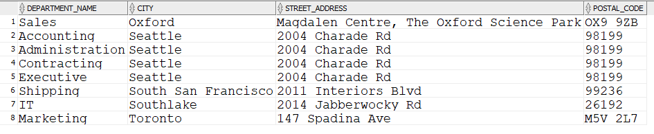

2)      Display full name of employees as a single field using format of **Last,** **First**, their hire date, salary, department name and city, but only for departments with names starting with an **A** or **S** sorted by department name and employee name.

**Statement:**

select trim(last_name) || ', ' || trim(first_name) "Full Name" , e.hire_date, e.salary, d.department_name, l.city

from employees e, locations l, departments d

where e.department_id = d.department_id

AND l.location_id = d.location_id

AND (department_name LIKE 'S%' OR department_name LIKE 'A%')

ORDER BY 4, 1;

**Output:**

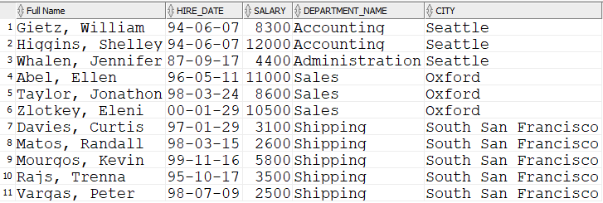

3)      Display the full name of the manager of each department in states/provinces of Ontario, California and Washington along with the department name, city , postal code and province name. Sort the output by city and then by department name.

**Statement:**

select trim(first_name) || ' ' ||trim(last_name) "Full Name", d.department_name, l.city, l.postal_code, l.state_province

from employees e, departments d, locations l

where e.employee_id = d.manager_id

and d.location_id = l.location_id

and l.state_province IN ('Ontario','California','Washington');

**Output:**

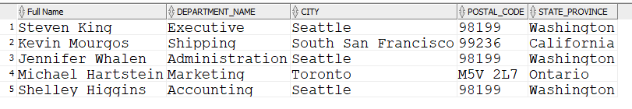

4)      Display employee’s last name and employee number along with their manager’s last name and manager number. Label the columns Employee, Emp#, Manager, and Mgr# respectively.

**Statement:**

select m.last_name “Employee”, m.employee_id “Emp#”, e.last_name “manager”, m.manager_id “Mgr#”

from employees e, employees m

where m.employee_id = e.manager_id;

**Output:**

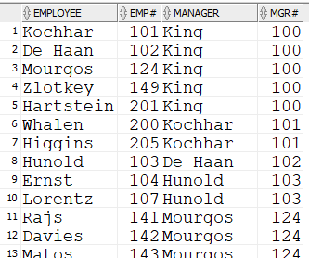

Rows:19